SESSION 11: RDBMS (CONTD.)

Assignment 2

1. Introduction .......................................................................................................................................... 3

2. Objective ............................................................................................................................................... 3

3. Prerequisites ......................................................................................................................................... 3

4. Associated Data Files ............................................................................................................................ 3

5. Problem Statement ............................................................................................................................... 3

6. Expected Output ................................................................................................................................... 3

7. Approximate Time to Complete Task ................................................................................................... 3

**1. Introduction**

This assignment will help you understand the concepts learnt in the session.

**2. Objective**

To understand and be able to manipulate SQL queries.

**3. Prerequisites**

Not applicable.

**4. Associated Data Files**

Use the Sakila schema, which can be found in following link (to be installed in your local system)

http://dev.mysql.com/doc/index-other.html("sakila database")

http://dev.mysql.com/doc/sakila/en/sakila.html(for full documentation)

**Requirements**

For each question, you are required to provide the following:

- The SQL query you used

- The answers

- Any assumptions you made

**5. Problem Statement**

1. Who is the customer who spent the most on rental movies? Return his/her customer id, first name and the amount spent.

**Ans:- use sakila;**

**SELECT customer.customer_id,customer.first_name,sum(payment.amount) AS AMOUNT_SPEND**

**FROM payment,customer**

**where customer.customer_id=payment.customer_id**

**GROUP BY customer.customer_id,customer.first_name**

**having AMOUNT_SPEND =(select max(amt)**

**from (select customer_id,sum(amount) amt from sakila.payment**

**group by customer_id ) as t);**

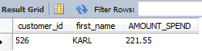

2. Give an interesting query of your own that is not already in the assignment. The query should involve at least two joins, HAVING clause and aggregation operation. Give the English explana-tion and the answer.

**Ans:- use world;**

**SELECT city.CountryCode,country.Name,country.region,countrylanguage.Language,**

**countrylanguage.Percentage,sum(country.population) AS total_population**

**FROM country**

**JOIN city ON country.Name = city.Name**

**JOIN countrylanguage ON city.CountryCode = countrylanguage.CountryCode**

**GROUP BY city.countrycode**

**HAVING sum(country.population)>100000**

**ORDER BY total_population DESC,country.Name;**

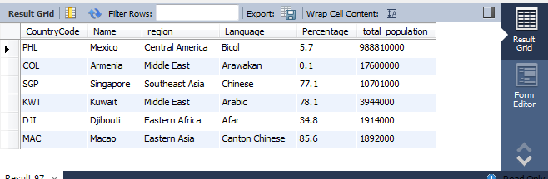

To get the result I have joined content (language, region and Percentage) and used one aggregation operation (sum function-to get the total population) after that used having clause to get the sum of total population >100000.

**6. Expected Output**

N/A